Jennifer Stegina

4 September 2019

CIS 250

**Unit 2 Graded Exercise 2**

The following questions come from the “Check your understanding” examples of each section of chapter 4 in your textbook.

After you are finished, please submit a Microsoft Word file that contains screenshots of the SQL queries and the output and include your name in a comment line in the SQL queries. Your document should be named **U2_GradedExercise2_Lastname.docx**.

(4-1) Question 1:

Create a copy of the *l_employees* table. Name it *sec0401_employees*.

Here is the reason you might want to do this. Later in this chapter you will learn how to change the data in a table. However, you should not make any changes to the data in the *l_employees* table because many of the examples in this book are based on it. If you make a change to the data in this table, the examples in the book might not work correctly.

Instead, you can make a new copy of the table and then you can change the data in the new copy. This allows you to practice changing the data and still keep the *l_employees* table unchanged so it works in all the examples from the book.

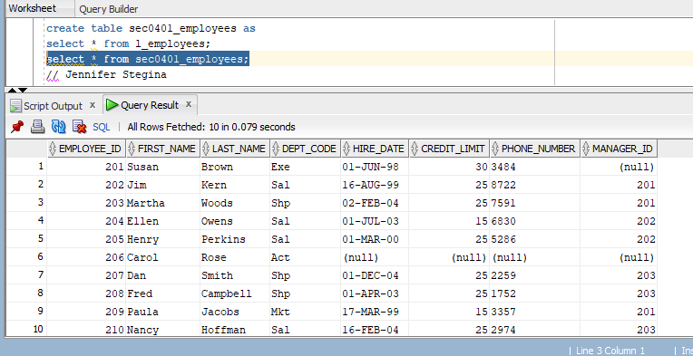

(4-2) Question 2:

Create a view of the *l_employees* table. Name it *sec0402_employees_view*



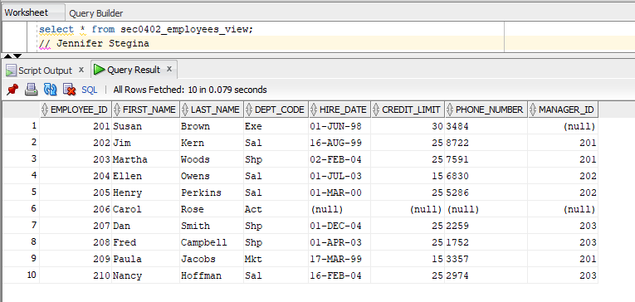

(4-5) Question 3:

Delete the table *sec0405_table_to_delete*.

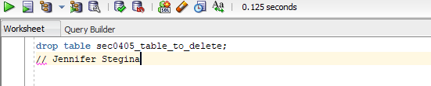

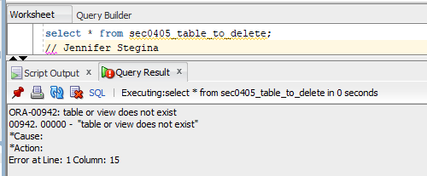

(4-6) Question 4:

Delete the view *sec0406_view_to_delete*.

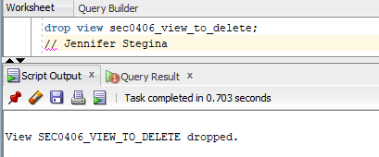

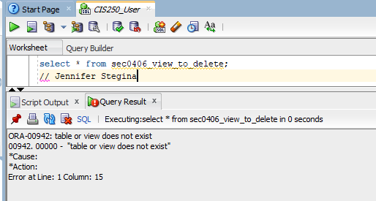

(4-9) Question 5:

Add a new row to the sec0409_employees table. Use the data:

*employee_id* = 301

*first_name* = Ellen

*last_name* = Perkins

*dept_code* = IT

*hire_date* = March 9, 2009

*credit_limit* = $20.00

*phone_number* = null

*manager_id* = 201

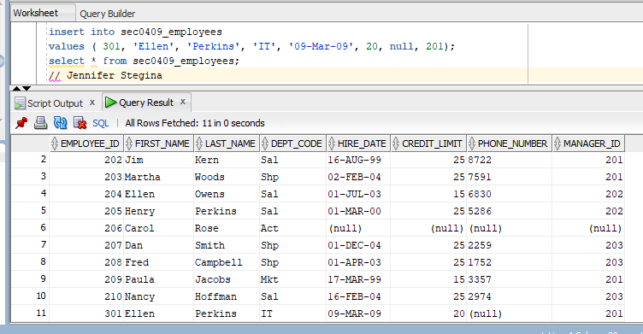

(4-10) Question 6:

Tables *sec0410_data2* and *sec0410_data1* have the same record structure. Each row has three columns: a number column, a text column, and a date column. Write an insert statement that puts all the rows of table *sec0410_data2* into table *sec0410_data1*.

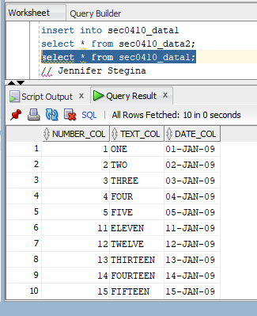

(4-11) Question 7:

In the *sec0411_employees* table, change the credit limit to $27.00 for all the employees who currently have a credit limit of $15.00 and also for any employee who has a null in the credit limit field.



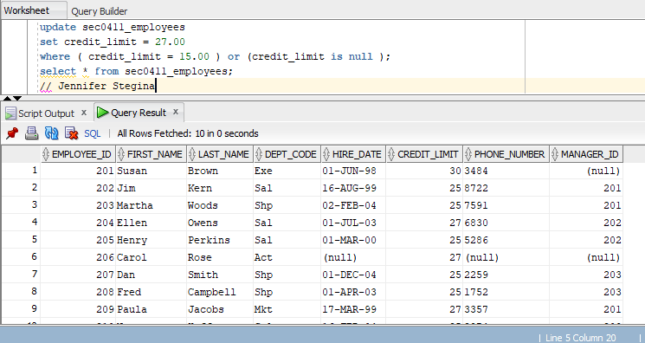

(4-12) Question 8:

In the *sec0412_employees* table, delete the rows with *employee_id* between 202 and 205.



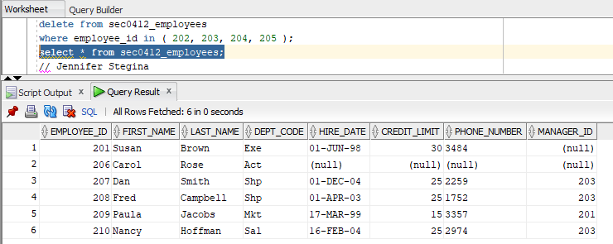

(4-15) Question 9:

Write SQL to delete the Sales Department (SAL) from the *sec0415_departments* table. This should work. Then apply the same SQL statement to the *l_departments* table. This time you will get an error message.

